

Insert School Logo

Semester One

Examination 2024

Question/Answer booklet

CHEMISTRY
UNIT 1

Name: __________________________________________________________________________________________

Teacher: _______________________________________________________________________________________

TIME ALLOWED FOR THIS PAPER

Reading time before commencing work: Ten minutes
Working time for the paper: Two and a half hours

MATERIALS REQUIRED/RECOMMENDED FOR THIS PAPER

To be provided by the supervisor:
This Question/Answer Booklet
Multiple-choice Answer Sheet
Chemistry Data Book

To be provided by the candidate:
Standard items: pens, pencils, eraser or correction fluid, ruler, highlighter.

Special items: calculators satisfying the conditions set by the SCSA for this subject.

IMPORTANT NOTE TO CANDIDATES
No other items may be taken into the examination room. It is your responsibility to ensure that you do not have any unauthorised notes or other items of a non-personal nature in the examination room. If you have any unauthorised material with you, hand it to the supervisor before reading any further.

Structure of this paper

Section | Number of questions available | Number of questions to be answered | Suggested working time  (minutes) | Marks available | Percentage of exam
Section One:  Multiple-choice | 25 | 25 | 50 | 25 | 25
Section Two:  Short answer | 8 | 8 | 60 | 61 | 35
Section Three:  Extended answer | 4 | 4 | 70 | 65 | 40
 |  |  |  | Total | 100
Final percentage |  | $\frac{}{\text{25}}$ x 25 + $\frac{}{\text{61}}$ x 35 + $\frac{}{\text{65}}$ x 40 = |  |  | %

Instructions to candidates

1. Answer the questions according to the following instructions.

Section One: Answer all questions on the separate Multiple-choice Answer Sheet provided. For each question shade the box to indicate your answer. Use only a blue or black pen to shade the boxes. If you make a mistake, place a cross through that square then shade your new answer. Do not erase or use correction fluid/tape. Marks will not be deducted for incorrect answers. No marks will be given if more than one answer is completed for any question.

Sections Two and Three: Write your answers in this Question/Answer Booklet.

2. When calculating numerical answers, show your working or reasoning clearly. Express numerical answers to the appropriate number of significant figures and include appropriate units where applicable.

3. You must be careful to confine your responses to the specific questions asked and to follow any instructions that are specific to a particular question.

4. Spare pages are included at the end of this booklet. They can be used for planning your responses and/or as additional space if required to continue an answer.
  - Planning: If you use the spare pages for planning, indicate this clearly at the top of the page.
  - Continuing an answer: If you need to use the space to continue an answer, indicate in the original answer space where the answer is continued, i.e. give the page number. Fill in the number of the question(s) that you are continuing to answer at the top of the page.

5. The Chemistry Data Book is not handed in with your Question/Answer Booklet.

Section One: Multiple-choice 25% (25 marks)

This section has 25 questions. Answer all questions on the separate Multiple-choice Answer Sheet provided. For each question, shade the box to indicate your answer. Use only a blue or black pen to shade the boxes. If you make a mistake, place a cross through that square then shade your new answer. Do not erase or use correction fluid/tape. Marks will not be deducted for incorrect answers. No marks will be given if more than one answer is completed for any question.

Suggested working time: 50 minutes.

1. Which one of the following lists contains only pure substances?

(a) air, copper chloride, zinc
(b) water, air, oxygen
(c) copper chloride solution, zinc, oxygen
(d) zinc, water, oxygen

- The X²⁻ ion has an electron configuration of 2,8,3. Which of the following statements is true based on this information?

- X is in period 2 and group 15
- X is in period 2 and group 1
- X is in period 3 and group 15
- X is in period 3 and group 1

3. Consider the line spectrum below.

This line spectrum is created by the movement of electrons

- within their existing energy levels.
- to energy levels further from the nucleus.
- to energy levels closer to the nucleus.
- from one atom to a different atom.

Questions 4, 5 and 6 refer to the atom represented in the following diagram.

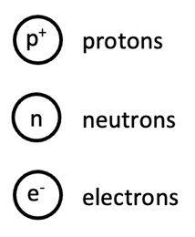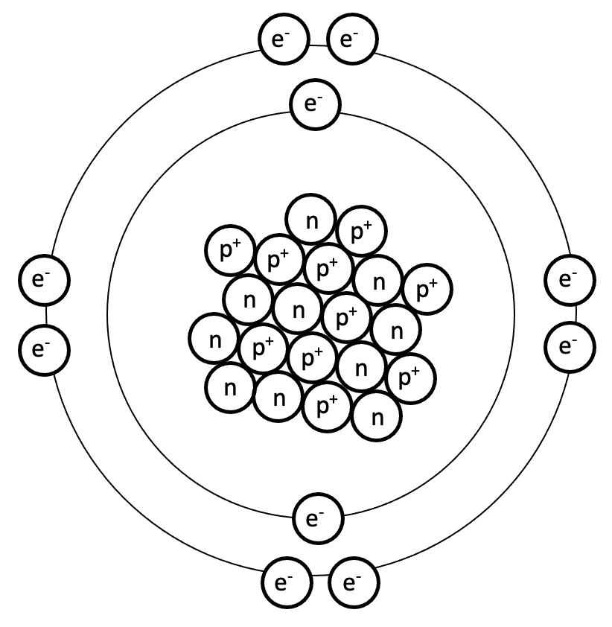

4. The atom was represented as a region consisting mostly of empty space, with a small dense nucleus in the centre, due to the work of

(a) Dalton.
(b) Thomson.
(c) Rutherford.
(d) Bohr.

5. The electrons were represented in specific energy levels or shells due to the work of

(a) Dalton.
(b) Thomson.
(c) Rutherford.
(d) Bohr.

6. This diagram represents an atom that is

(a) unstable.
(b) excited.
(c) in group 8.
(d) a non-metal.

7. Which of the following statements regarding relative atomic mass is not correct?

The relative atomic mass of an element

- is calculated from its isotopic composition.
- is a weighted average.
- is calculated by comparison to 1/12th the mass of a carbon-12 atom.
- has the units grams per mole (g mol⁻¹).

8. Identify the correct charge carried by each of these ions.

sulfite silver nitride
- -3 +2 -1
- -2 +1 -3
- -2 +1 -1
- -3 +3 -3

Questions 9 and 10 refer to the information in the following table.

Consider the table below, which provides information regarding some of the physical properties of substances W, X, Y and Z.

Species | Melting point (°C) | Conductivity as a solid | Conductivity as a liquid
W | -2 | no | no
X | 1033 | no | yes
Y | 835 | yes | yes
Z | 1404 | no | no

9. Which of these substances is likely to be the best thermal conductor?

- W
- X
- Y
- Z

10. Which of these substances is most likely to be an ionic substance?

- W
- X
- Y
- Z

11. A beaker held 6.022 x 10²³ formula units of solid lithium hydrogen phosphate. Which of the following statements must therefore be correct?

The sample would contain

- one mole of lithium.
- one mole of hydrogen.
- one mole of phosphorus.
- one mole of oxygen.

- (i) and (iii) only.
- (i) and (iv) only.
- (ii) and (iii) only.
- (i), (ii) and (iii) only.
12. The metallic character of an element is related to which property?

- High atomic number.
- Large atomic radius.
- Low first ionisation energy.
- Low electronegativity.

13. How many moles of hydroxide ions are there in 3 moles of chromium(III) hydroxide?

(a) 3
(b) 6
(c) 9
(d) 12

14. Which one of these is an endothermic change?

(a) petrol burning
(b) H₂O(g) → H₂O(ℓ)
(c) an ice-cream melting
(d) H₂(g) + ½ O₂(g) → H₂O(g) + 242 kJ

15. Ionic substances are brittle because

(a) ions with like charges experience a repulsive force when they align.
(b) the ionic lattice requires an extremely large force to disrupt it.
(c) all electrons in the ionic network are highly localised.
(d) an applied force will disrupt the sea of delocalised electrons.

Questions 16 and 17 refer to the following information.

A chemistry student was tasked with obtaining a sample of magnesium chloride powder, MgCl₂(s), from the mixture below.

oil
MgCl₂(aq)
ZnCO₃(s)

16. The student began by removing the oil from the mixture. This could be accomplished by

- decanting.
- sieving.
- filtration.
- evaporation.

17. The magnesium chloride powder could then be obtained by the sequential processes of

- evaporation followed by decanting.
- evaporation followed by filtration.
- filtration followed by sieving.
- filtration followed by evaporation.

18. Which of the following statements regarding an atom of carbon in the ground state is not correct?

- It has 4 electron levels occupied.
- It has 4 valence electrons.
- It has a valency of 4.
(d) It has 6 protons.

19. For any given element on the periodic table, the element directly below it should have the same

- atomic radius.
- valency.
- first ionisation energy.
- electronegativity.

20. Which of the following statements can be used to explain why the rate of reaction between magnesium ribbon and dilute hydrochloric acid will decrease as the reaction proceeds?

- The surface area of magnesium will increase as the ribbon becomes smaller.
- The concentration of H⁺ ions falls as the acid gets used up.
- The reaction is exothermic, meaning that there is less energy available for the reaction.

- (i) only
- (i) and (ii) only
- (ii) only
- (i), (ii) and (iii)

Questions 21 and 22 refer to the information below.

A group of chemistry students was investigating factors that may affect reaction rate.

They placed an equal volume and concentration of hydrochloric acid, HCl(aq), into three (3) beakers. They then weighed out three (3) equal masses of sodium carbonate, Na₂CO₃(s). The first Na₂CO₃ sample was a solid lump, the second was in small pieces and the third was a powdered sample.

HCl(aq)
Na₂CO₃(s)

Each sample of solid Na₂CO₃ was added to a different beaker of HCl and the time taken for the solid to dissolve was measured and recorded.

21. State the independent and dependent variables in this investigation.

Independent Dependent
- Mass of Na₂CO₃ Volume of HCl
- Subdivision of Na₂CO₃ Time for Na₂CO₃ to dissolve
- Volume of HCl Subdivision of Na₂CO₃
- Time for Na₂CO₃ to dissolve Mass of Na₂CO₃

22. Using knowledge of the collision theory, predict and explain the expected results of this experiment.

- The rate of reaction was the same in each beaker because the same mass of solid, and therefore the same number of collisions, is occurring.
- The rate of reaction increased as the subdivision of Na₂CO₃ increased because a larger proportion of particles were able to overcome the activation energy barrier.
- The rate of reaction would have been the same in each beaker provided the students made sure that all the controlled variables were kept constant.
- The rate of reaction increased as the subdivision of Na₂CO₃ increased due to a larger surface area of reactants available for collision.

23. In a mass spectrometer, ionised species are deflected by a magnetic field. Which of the following species would be least deflected, assuming the same magnetic field was applied?

- ¹⁶O⁺.
- ¹⁹F⁺.
- ³²S⁺.
- ³⁵Cl⁺.

24. When two solutions, silver nitrate and sodium chloride are mixed, a precipitate of silver chloride forms in a solution of sodium nitrate. A correctly written and balanced chemical equation to represent this reaction is
(a) AgNO₃(aq) + 2NaCl(aq) → AgCl(s) + 2NaNO₃(aq)
(b) Ag(NO₃)₂(aq) + 2NaCl (aq) → AgCl₂(s) + 2NaNO₃(aq)
(c) AgNO₃(aq) + NaCl(aq) → AgCl(s) + NaNO₃(aq)
(d) 2AgNO₃(aq) + 2NaCl(aq) → 2AgCl(s) + NaNO₃(aq)

25. Identify the coefficients which would correctly balance the chemical equation below.

___ Cu(s) + ___ HNO₃(aq) → ___ Cu(NO₃)₂(aq) + ___ H₂O(l) + ___ NO₂(g)

(a) 1, 4, 1, 2, 2
(b) 1, 2, 1, 1, 1
(c) 2, 6, 2, 3, 2
(d) 2, 4, 1, 2, 2

End of Section One

Section Two: Short answer 35% (61 marks)

This section has eight (8) questions. Answer all questions. Write your answers in the spaces provided.

Supplementary pages for planning/continuing your answers to questions are provided at the end of this Question/Answer booklet. If you use these pages to continue an answer, indicate at the original answer where the answer is continued, i.e. give the page number.

Suggested working time: 60 minutes.

Question 26 (10 marks)

Consider the incomplete information regarding species W, X, Y and Z in the following table.

Species | Symbol | Number of protons | Number of neutrons | Electron configuration | Mass number
W |  | 11 | 11 | 2, 8, 1
X | ${}_{ }^{\text{31}}{\text{P}}$³⁻ | 15 |  |  | 31
Y |  |  | 12 | 2, 8 | 24
Z | $${}_{ }^{\text{36}}{\text{C}\text{l}}$$ |  | 19 |  | 36

(a) Complete the table above. (8 marks)

(b) Which of these species is a cation? Describe how a cation is formed. (2 marks)

________________________________________________________________________

________________________________________________________________________

________________________________________________________________________

________________________________________________________________________

________________________________________________________________________

Question 27 (6 marks)

Complete the table below, by writing either the name or the formula of the compound.

Name | Formula
sodium dichromate
 | H₂O₂
 | FeCl₃
zinc hydroxide
boron trihydride
 | (NH₄)₃P

Question 28 (12 marks)

Antimony (Sb) is a ‘semi-metal’ or ‘metalloid’ which appears silvery-grey in pure form. Its main applications are in flame retardants, batteries and pigments.

(a) State the location of antimony on the periodic table. (2 marks)

Period number: ____________________

Group number: ____________________

Mass spectrometry was performed on a sample of antimony. It was found to be comprised of two (2) naturally occurring isotopes, one of which was antimony-121.

The incomplete readout from the mass spectrometer is shown below.

The mass spectrometer determined the relative atomic mass of antimony to be 121.8.

(b) Determine the identity of the other isotope of antimony. Support your answer with relevant calculations. (3 marks)

(c) Use your answer to part (b) to complete the mass spectrometer readout above. (1 mark)

Due to adverse side effects, the legal maximum contaminant level of antimony in drinking water is set at 6 parts per billion (i.e. 6 ng per gram).

A sample of drinking water was analysed by atomic absorption spectroscopy (AAS) to determine if any antimony was present. The AAS calibration curve for antimony is shown below.

(d) Briefly outline how this calibration curve would have been obtained. (3 marks)

________________________________________________________________________

________________________________________________________________________

________________________________________________________________________

________________________________________________________________________

________________________________________________________________________

________________________________________________________________________

The absorbance reading from the sample of drinking water was found to be 0.6.

(e) Calculate the number of moles of antimony that a person would ingest, if 1 g of this drinking water was consumed. (Note: 1 ng = 1.0 x 10⁻⁹ g) (3 marks)

Question 29 (5 marks)

Consider the six (6) gas samples, labelled A – F, shown in the diagrams below. Different types of atoms are represented by different patterns and shading. Using these diagrams, answer the questions below.

B
D
F
C
A
E

Which samples are pure substances?
Which sample could be chlorine gas?
Which sample is a mixture of elements?
Which samples contain a compound?
Suggest the identity of gas sample B.

Question 30 (8 marks)

Platinum is one of the least reactive metals, and can therefore be found in an uncombined state, as well as in some nickel and copper ores.

It has a high melting point of 1768 °C, allowing it to be used as a catalyst for reactions occurring at high temperatures. Platinum wire is a common type of laboratory electrode, and can be easily manufactured since platinum is the most ductile of all metals. The high electrical conductivity of platinum also makes it suitable for use in electrical circuits.

(a) Explain, in terms of structure and bonding, these bolded properties of platinum. (6 marks)

________________________________________________________________________

________________________________________________________________________

________________________________________________________________________

________________________________________________________________________

________________________________________________________________________

________________________________________________________________________

________________________________________________________________________

________________________________________________________________________

________________________________________________________________________

________________________________________________________________________

________________________________________________________________________

________________________________________________________________________

________________________________________________________________________

Another substance that is commonly used to make electrodes is graphite. It also displays high electrical conductivity, however it has an even higher melting point of 3650 °C.

(b) Identify the type of bonding that accounts for the higher melting point of graphite. Give a brief description of this type of bonding. (2 marks)

________________________________________________________________________

________________________________________________________________________

________________________________________________________________________

________________________________________________________________________

________________________________________________________________________

Question 31 (6 marks)

In Australia, fluoride is added to the public water supply in order to prevent tooth decay. Water fluoridation usually involves adding one of the following compounds into the water supply;

- sodium fluoride, NaF
- fluorosilicic acid, H₂SiF₆
- sodium fluorosilicate, Na₂SiF₆

At room temperature, one of these substances is described as a ‘transparent colourless liquid’.

(a) Identify which substance is likely to match this description and justify your answer in terms of the bonding present. (2 marks)

________________________________________________________________________

________________________________________________________________________

________________________________________________________________________

________________________________________________________________________

(b) Calculate the percentage composition of sodium fluorosilicate (Na₂SiF₆). (4 marks)

Question 32 (6 marks)

A sample of calcium carbonate powder was placed into an empty beaker, that was sitting on a laboratory benchtop. A sample of hydrochloric acid was then poured into the beaker. The powder dissolved and fizzing was observed. The reaction that took place can be represented by the enthalpy change diagram below.

Reactants
Products
Progress of reaction
Enthalpy

(a) Identify one (1) component of; (2 marks)

- the system. _________________________________________________

- the surroundings. _________________________________________________

(b) Classify this reaction as endothermic or exothermic. (1 mark)

________________________________________________________________________

(c) Identify whether the beaker would have felt cooler or warmer when the reaction was taking place, compared to before the acid was added. (1 mark)

________________________________________________________________________

(d) Compare the energy associated with the bond breaking and bond making processes involved in this reaction. (2 marks)

________________________________________________________________________

________________________________________________________________________

________________________________________________________________________

________________________________________________________________________

________________________________________________________________________

________________________________________________________________________

Question 33 (8 marks)

Most phosphoric acid is manufactured from fluorapatite, Ca₅(PO₄)₃F, in a process which can be represented by the chemical equation below. The molar mass of fluorapatite is 504.31 g mol⁻¹.

Ca₅(PO₄)₃F(s) + 5 H₂SO₄(aq) → 3 H₃PO₄(aq) + 5 CaSO₄(s) + HF(aq)

A 3.24 kg sample of impure fluorapatite was reacted with excess sulfuric acid, and this produced 1.83 kg of phosphoric acid.

(a) Calculate the number of moles of phosphoric acid produced. (2 marks)

(b) Calculate the percentage purity of the fluorapatite used. The molar mass of fluorapatite is 504.31 g mol⁻¹. (4 marks)

(c) Calculate the mass of calcium sulfate that would have been produced. (2 marks)

End of Section Two

This page has been left blank intentionally

Section Three: Extended answer 40% (65 marks)

This section contains four (4) questions. You must answer all questions. Write your answers in the spaces provided below.

Where questions require an explanation and/or description, marks are awarded for the relevant chemical content and also for coherence and clarity of expression. Lists or dot points are unlikely to gain full marks.

Final answers to calculations should be expressed to the appropriate number of significant figures.

Supplementary pages for planning/continuing your answers to questions are provided at the end of this Question/Answer booklet. If you use these pages to continue an answer, indicate at the original answer where the answer is continued, i.e. give the page number.

Suggested working time: 70 minutes.

Question 34 (17 marks)

The first ionisation energy values for the period 2 and period 3 elements are plotted on the graph below.

(a) On the graph above, label each line to indicate which represents the period 2 elements and which represents the period 3 elements. (1 mark)

(b) Justify the choice you made in part (a). Your answer should include a definition of first ionisation energy. (4 marks)

________________________________________________________________________

________________________________________________________________________

________________________________________________________________________

________________________________________________________________________

________________________________________________________________________

________________________________________________________________________

________________________________________________________________________

________________________________________________________________________

(c) Explain why the general trend in first ionisation energy shows an increase across a period. (3 marks)

________________________________________________________________________

________________________________________________________________________

________________________________________________________________________

________________________________________________________________________

________________________________________________________________________

________________________________________________________________________

________________________________________________________________________

Whilst the general trend in electronegativity also shows an increase across a period, it does not include the group 18 elements (unlike first ionisation energy).

(d) Explain why the group 18 elements in period 2 and 3 are not assigned an electronegativity value. Your answer should include a definition of electronegativity. (3 marks)

________________________________________________________________________

________________________________________________________________________

________________________________________________________________________

________________________________________________________________________

________________________________________________________________________

________________________________________________________________________

________________________________________________________________________
Consider all of the elements in period 2 and 3.

(e) Identify which has the; (2 marks)

- smallest atomic radius. ___________________________________________

- largest atomic radius. ___________________________________________

Assume X and Y can represent the symbol of any two elements from period 3. A compound was formed from these two elements, which had the formula XY₂.

(f) Identify two elements that could have produced compound XY₂ if the bonding within the compound was: (2 marks)

- ionic. _______________________________________________________

- covalent. _______________________________________________________

(g) Describe the difference between ionic and covalent bonding, in terms of electron behaviour. (2 marks)

________________________________________________________________________

________________________________________________________________________

________________________________________________________________________

________________________________________________________________________

________________________________________________________________________

This page has been left blank intentionally

Question 35 (17 marks)

Comet ‘C/2022 E3’ was visible from Earth during January 2023.

One of the distinctive features of this comet was the green glow it emitted. This green colour was caused by the presence of diatomic carbon, C₂(g). When diatomic carbon is excited by UV radiation from the Sun, it emits green light in the same manner as a flame test.

(a) Describe how UV radiation can result in diatomic carbon becoming ‘excited’. (2 marks)

________________________________________________________________________

________________________________________________________________________

________________________________________________________________________

________________________________________________________________________

________________________________________________________________________

________________________________________________________________________

________________________________________________________________________

(b) Describe how the excited diatomic carbon is then able to produce this distinctive green light. (3 marks)

________________________________________________________________________

________________________________________________________________________

________________________________________________________________________

________________________________________________________________________

________________________________________________________________________

________________________________________________________________________

________________________________________________________________________

________________________________________________________________________

There are many carbon allotropes that have been identified; two of the most well-known being diamond and graphite.

(c) Describe how diamond and graphite are structurally different from one another. Use diagrams to support your answer. (6 marks)

________________________________________________________________________

________________________________________________________________________

________________________________________________________________________

________________________________________________________________________

________________________________________________________________________

________________________________________________________________________

________________________________________________________________________

________________________________________________________________________

Carbon has two naturally occurring isotopic forms; carbon-12 and carbon-13.

(d) Define an isotope. (1 mark)

________________________________________________________________________

________________________________________________________________________

________________________________________________________________________

Analysis by mass spectrometry has determined that 98.93% of all carbon is the carbon-12 isotope. Therefore, most molecules of diatomic carbon are composed of two atoms of carbon-12.

Consider, however, a molecule of diatomic carbon formed from two atoms of carbon-13.

(e) State whether this molecule, when excited, would be likely to emit the same green light observed from comet C/2022 E3. Justify your answer. (2 marks)

________________________________________________________________________

________________________________________________________________________

________________________________________________________________________

________________________________________________________________________

________________________________________________________________________

________________________________________________________________________

A sample of solid graphite was vaporised, in order to use the resultant carbon vapour to produce fullerenes. From this vapour, a 0.0344 g sample of diatomic carbon was isolated.

(f) Calculate the mass of carbon-13 atoms likely to be present in this sample. (3 marks)

Question 36 (15 marks)

A group of chemistry students were asked to experimentally determine the molar heat of combustion of benzene. Molar heat of combustion is defined as ‘the quantity of heat released by the combustion of one mole of a substance’.

They devised a method which involved setting up the following apparatus.

thermometer
water
open can
spirit burner
benzene
tripod

The molar heat of combustion for benzene is known to be 3265 kJ mol⁻¹.

(a) Write a balanced thermochemical equation for the combustion of benzene (C₆H₆) in excess oxygen to produce carbon dioxide and water. (3 marks)

- Sketch an energy profile diagram for the combustion of benzene.
(Include the terms: enthalpy (H), progress of reaction, reactants, products, Ea and ΔH).
(5 marks)

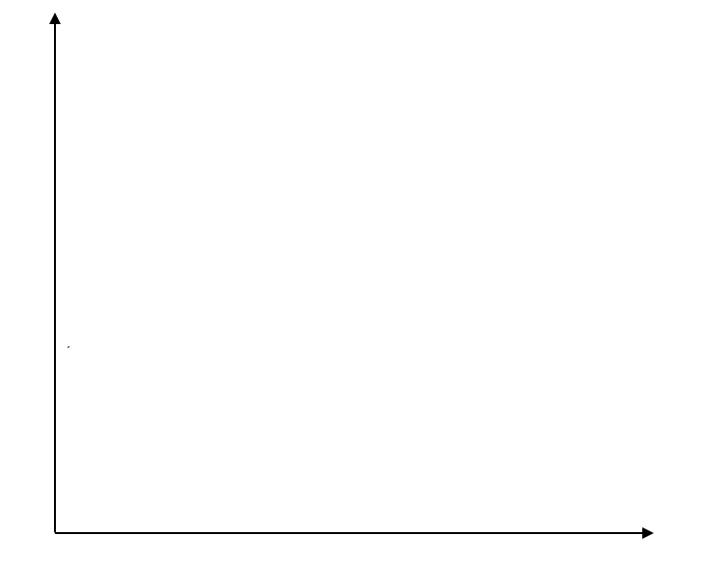

The students then conducted the experiment. They recorded the initial mass of the burner containing benzene, as well as the initial temperature of the water. They then lit the wick and allowed the benzene to burn for 5 minutes. The final mass of the beaker and final temperature of the water were then recorded.

The data recorded by the students is provided in the table below.

Mass of burner before heating | 149.33 g
Mass of burner after heating | 148.21 g
Temperature of water before heating | 21.6 °C
Temperature of water after heating | 63.1 °C

Combustion is generally considered to be an exothermic process.

(c) Justify how the data collected by the students supports this statement. (2 marks)

________________________________________________________________________

________________________________________________________________________

________________________________________________________________________

________________________________________________________________________

(d) Calculate the number of moles of benzene that reacted. (2 marks)

The students used the measured temperature change to calculate that 43.24 kJ of heat energy had been transferred to the water.

(e) Calculate the experimentally determined molar heat of combustion of benzene (kJ mol⁻¹). (1 mark)

The experimental value calculated by the students was lower than the accepted value of 3265 kJ mol⁻¹. When they repeated the experiment several times, the students found all the results obtained were consistently lower than the accepted value.

(f) State whether this suggests the presence of random or systematic error. (1 mark)

________________________________________________________________________

(g) Identify one (1) potential sources of this type of error. (1 mark)

________________________________________________________________________

________________________________________________________________________

________________________________________________________________________

________________________________________________________________________

Question 37 (16 marks)

Sodium chloride is a white, crystalline solid at room temperature. Commonly known as table salt, its main household uses are as a preservative and condiment. It is also used for de-icing roads in snowy climates, in addition to the production of various chemicals.

Water is a colourless, transparent liquid at room temperature. Water covers approximately 70% of the Earth’s surface, and is essential for all known forms of life.

(a) Identify the type of bonding exhibited by these substances. (2 marks)

Sodium chloride
Water

Water is also known as the ‘universal solvent’. When solid sodium chloride and liquid water are mixed, a saltwater solution is formed, NaCl(aq).

The properties of sodium chloride solution vary greatly from that of its two components. The table below summarises some of these differences.

 | Melting point (°C) | Electrical conductivity
Solid sodium chloride | 801 | No
Liquid water | 0 | No
Sodium chloride solution | – | Yes

(b) Explain, in terms of structure and bonding, why there is such a difference in the melting point of sodium chloride and water. (6 marks)

________________________________________________________________________

________________________________________________________________________

________________________________________________________________________

________________________________________________________________________

________________________________________________________________________

________________________________________________________________________

________________________________________________________________________

________________________________________________________________________

________________________________________________________________________
(c) Explain, in terms of structure and bonding, why solid sodium chloride and liquid water are each unable to conduct electricity, but when mixed together the resulting sodium chloride solution can conduct electricity. (5 marks)

________________________________________________________________________

________________________________________________________________________

________________________________________________________________________

________________________________________________________________________

________________________________________________________________________

________________________________________________________________________

________________________________________________________________________

________________________________________________________________________

________________________________________________________________________

________________________________________________________________________

________________________________________________________________________

________________________________________________________________________

The apparatus below could be used to separate the sodium chloride solution back into its original components.
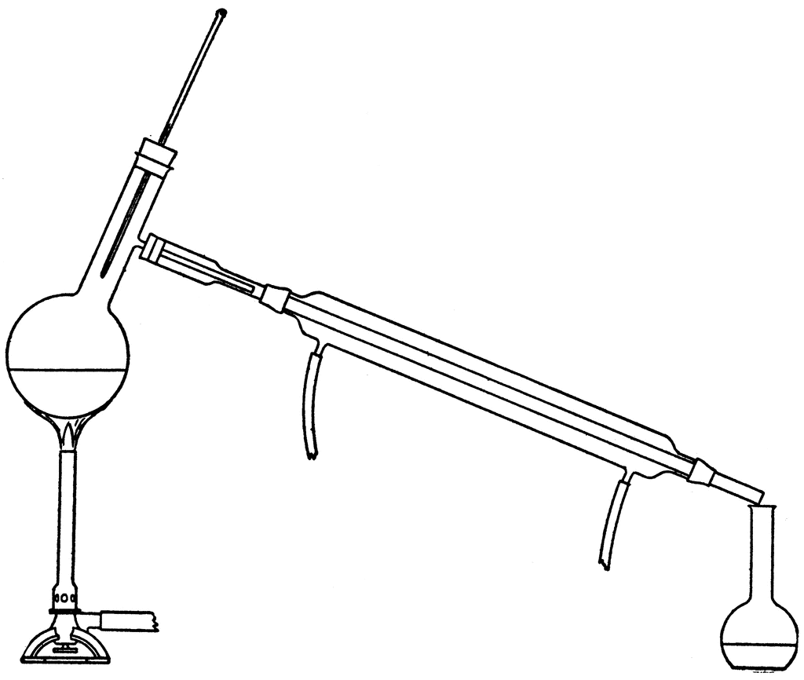
NaCl(aq)

(d) Identify the name of this separation technique. (1 mark)

________________________________________________________________________

(e) Label on the diagram above, where the solid sodium chloride and liquid water would each be found, upon completion of the separation process. (2 marks)

End of questions
Additional working space

Question number(s): ……………………

Spare grid – Question 28

Additional working space

Question number(s): ……………………

Additional working space

Question number(s): ……………………

References

Question 39 – distillation apparatus
https://etc.usf.edu/clipart/23400/23403/distillation_23403.htm
Alexander Smith, Intermediate Text Book of Chemistry (New York: The Century Co, 1920) 68

WATP acknowledges the permission of the School Curriculum and Assessment Authority in providing instructions to students.

